## **🪟 For Windows**

### **✅ Step 1: Download Java (JDK)**

1. Go to the [Oracle JDK Download page](https://www.oracle.com/java/technologies/javase-downloads.html) or use [OpenJDK](https://jdk.java.net/).
2. Download the **Java SE Development Kit (JDK)** for Windows.
3. Run the installer and complete the installation.

📍 By default, JDK installs to:  
 C:\Program Files\Java\jdk-<version>

### **✅ Step 2: Set Environment Variables**

#### **🛠 Set JAVA_HOME**

1. Right-click on **This PC** → **Properties**
2. Click **Advanced system settings**
3. Click **Environment Variables**
4. Under **System variables**, click **New**:  
   * **Variable name**: JAVA_HOME
   * **Variable value**: C:\Program Files\Java\jdk-<version>

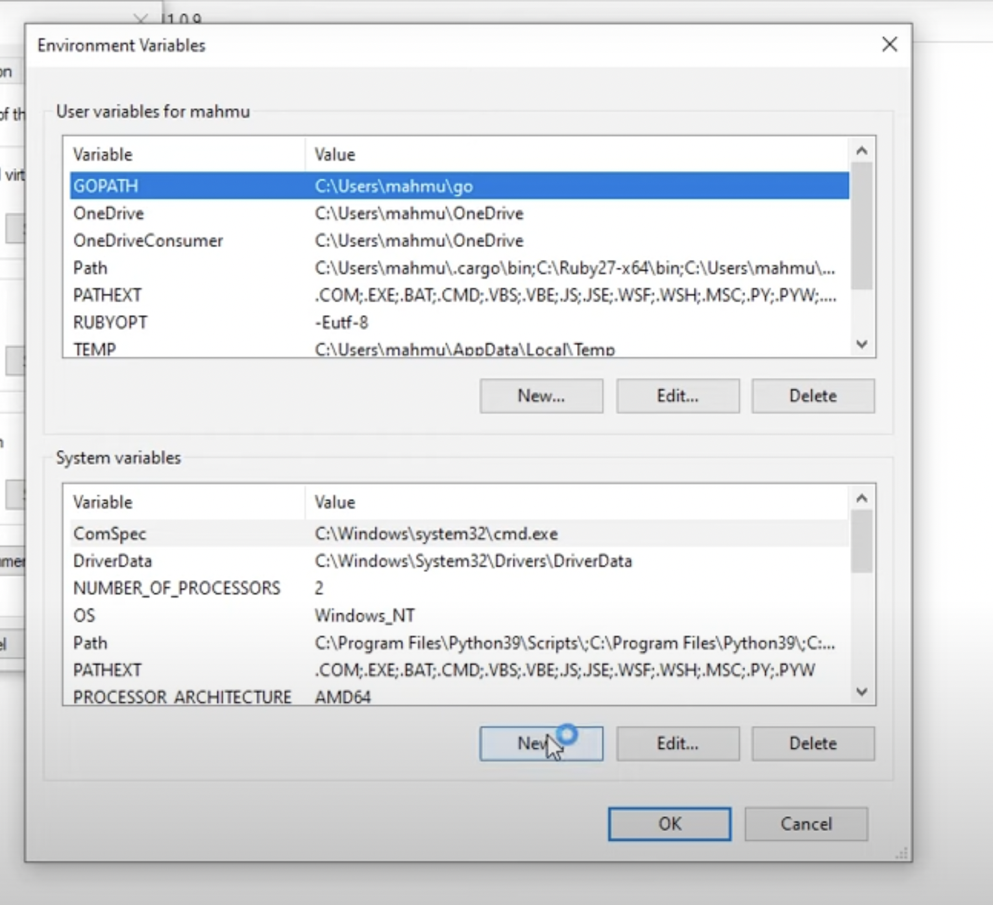

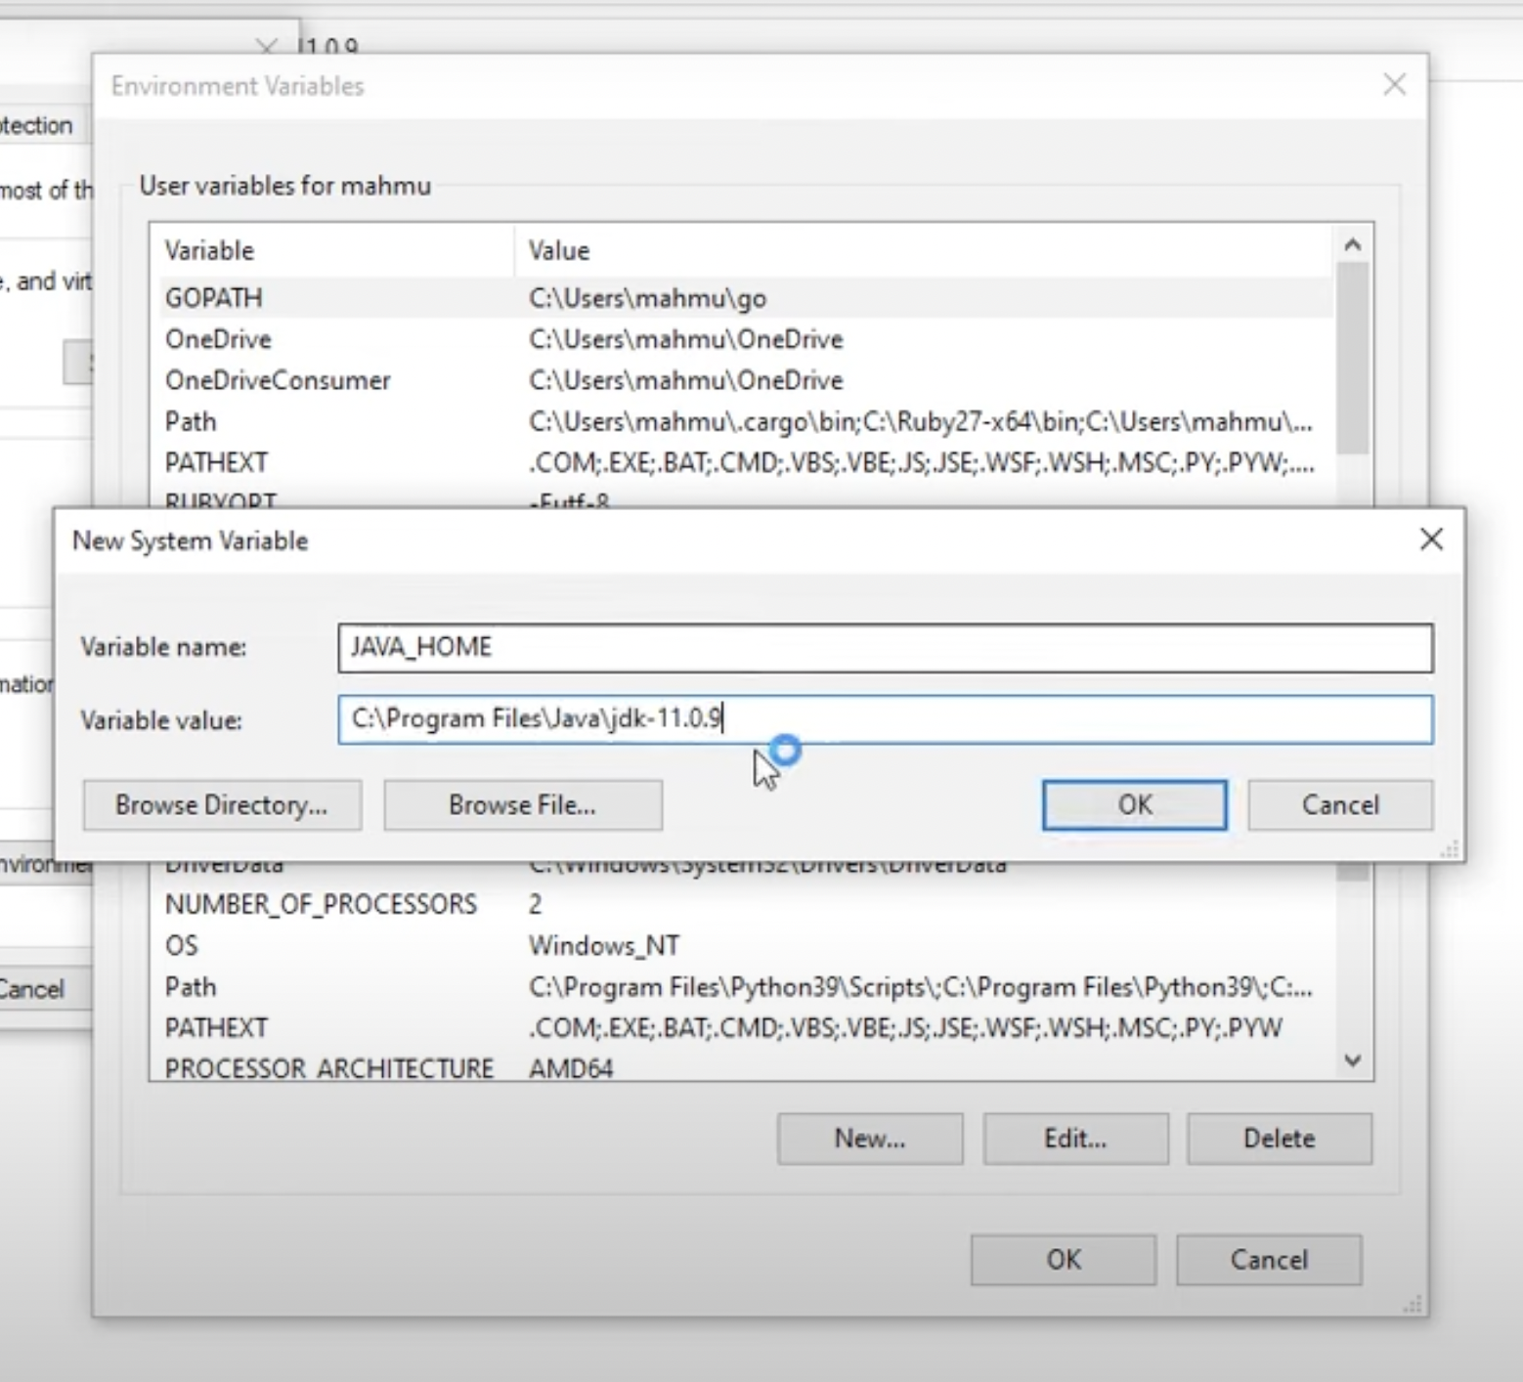

#### **🛠 Add Java to PATH**

1. In the same **Environment Variables** window:
2. Find the Path variable under **System variables**, and click **Edit**
3. Click **New** and add:  
   %JAVA_HOME%\bin

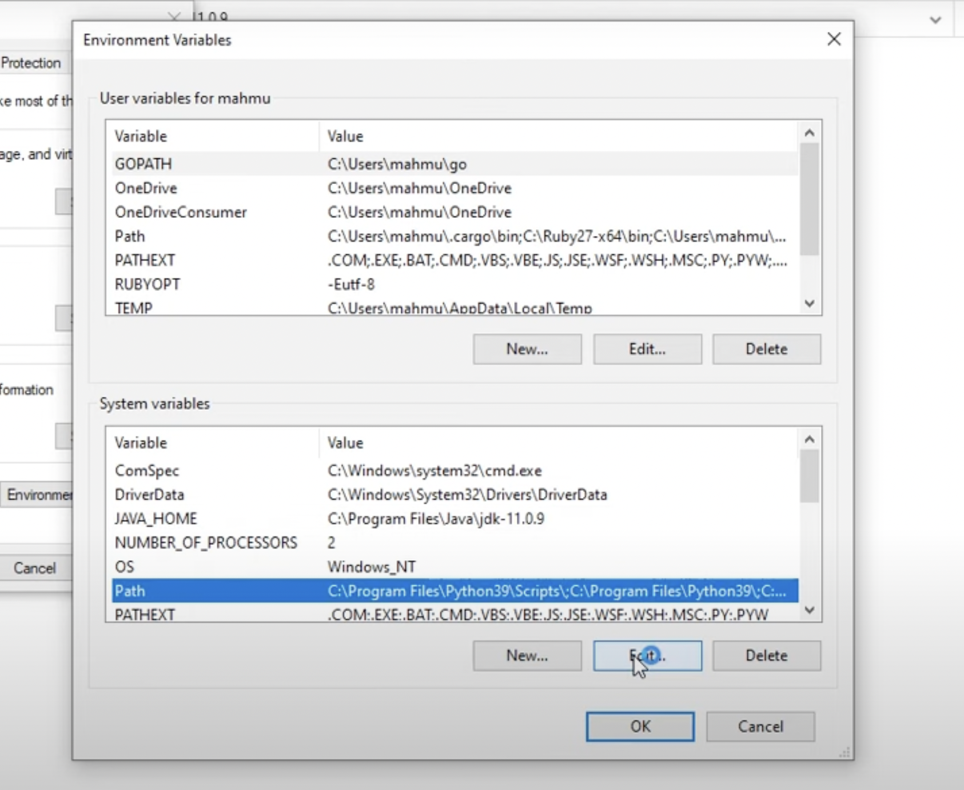

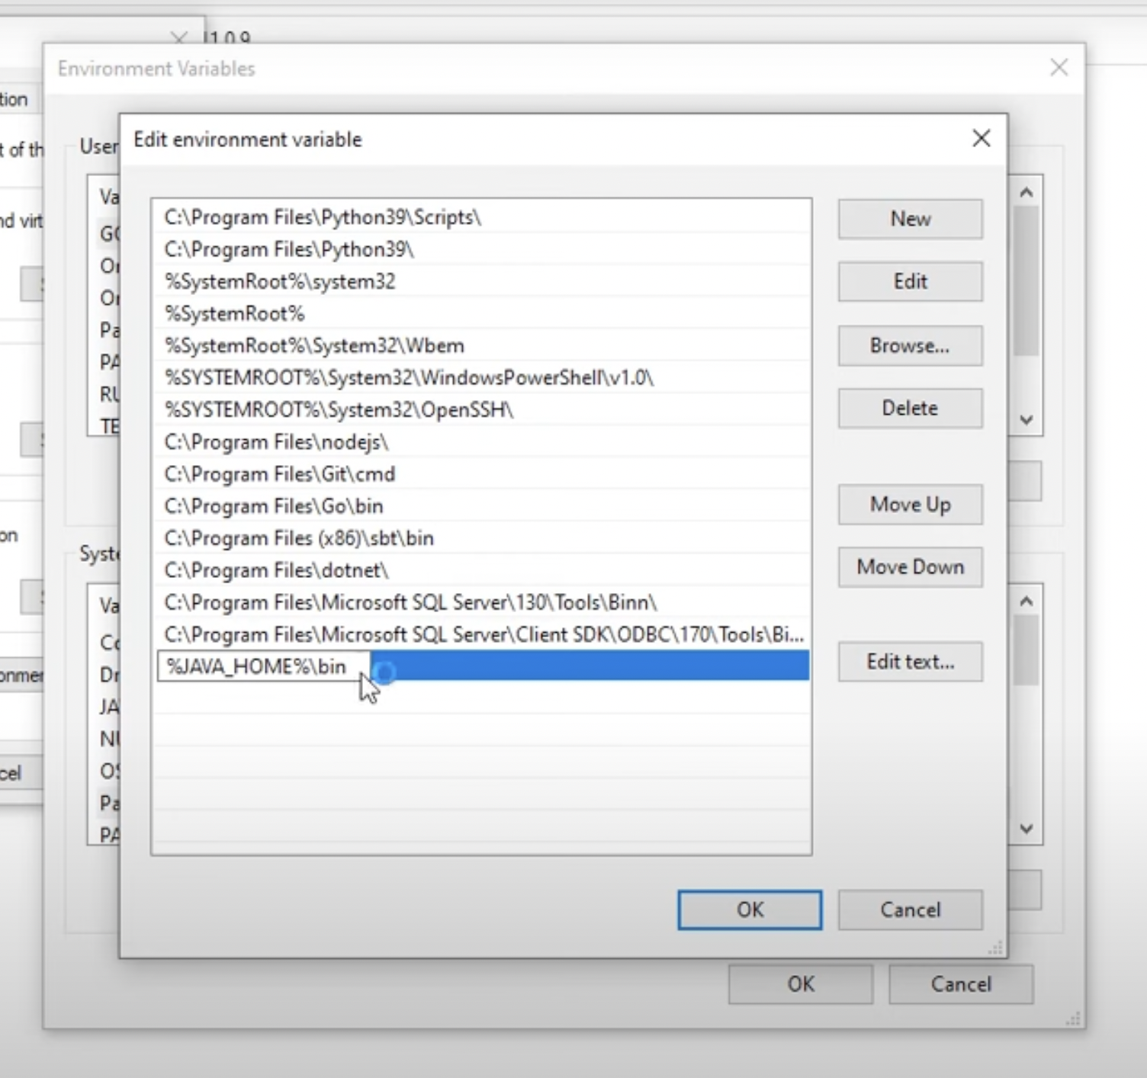

### **✅ Step 3: Verify Installation**

Open **Command Prompt** and run:

java --version

javac --version

You should see the installed version printed.